Project: | Moffat Bay Lodge - Mod 8
Course: | CSD 460
Description: | Module 8 Contact Us and Reservation History functional testing
Date: | 2026/09/20
TABLE OF CONTENTS
Verify Reservation Lookup Connects to the Database 3
Verify Reservation Data Matches MySQL Data 6
Verify Reservation Details Expand 10
Verify No History Message 15
Reservation History Requires a Customer ID 19
Reservation History Returns the Seeded Reservation with Line Items 21
About Page Loads with the Contact Us Section 23
Contact Us Form Inserts a New Message into the Database 25

For each test, the developer should: provide a test description, a test objective, the developer name and date tested. For each step, fill out the actions to be taken and describe the expected results, and indicate yes or no for each step depending upon the result. The peer tester should provide their name, date tested, indicate yes or no for each step depending upon the result, and a screenshot (thumbnail) of the result.

Test 1 | Verify Reservation Lookup Connects to the Database
 | Test Objective: Verify that the Reservation Lookup page successfully connects to the MySQL database through the API and retrieves an existing reservation. | Developer: Rashai Robertson  Date tested: 2026/09/18 | Peer tester: Tiffany Davidson  Date tested: 2026/09/19
Step | Action | Expected results: | Developer pass/fail | Tester pass/fail  + Screenshot
1 | Start the MySQL database and the Reservation Lookup API/server. | The database and API start successfully without errors. | Pass | Pass  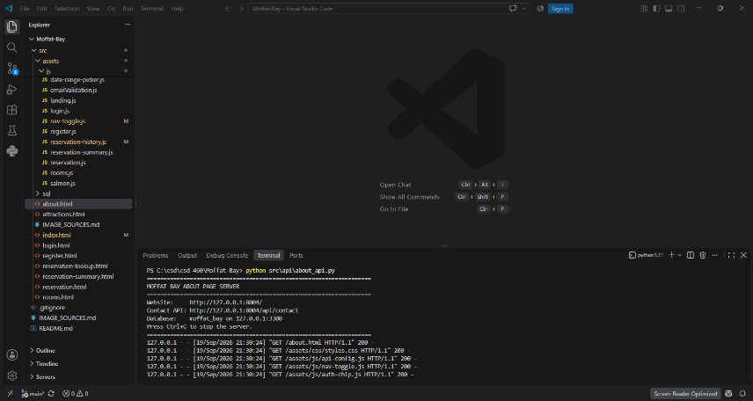
2 | Open the Reservation Lookup page in the browser. | The Reservation His page loads correctly and displays the lookup form. | Pass | Pass  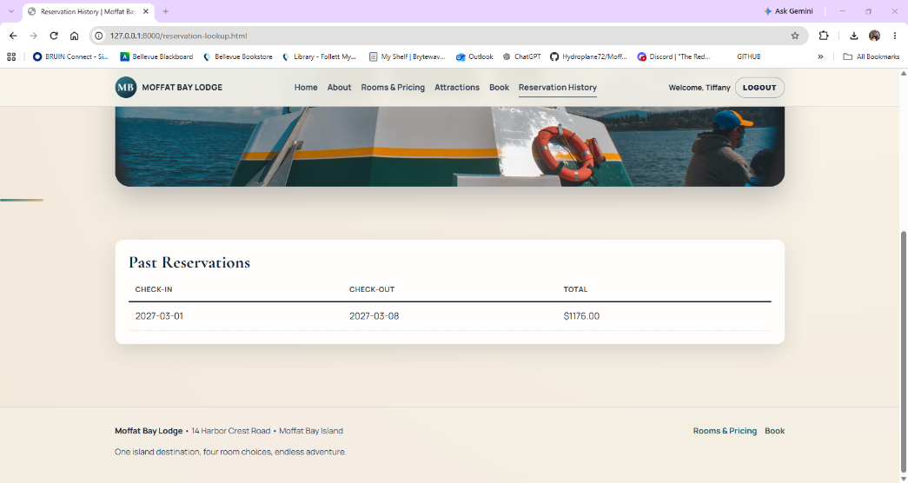
3 | Log in using an account that has an existing reservation. | Login succeeds, and the customer's session information is stored. | Pass | Pass  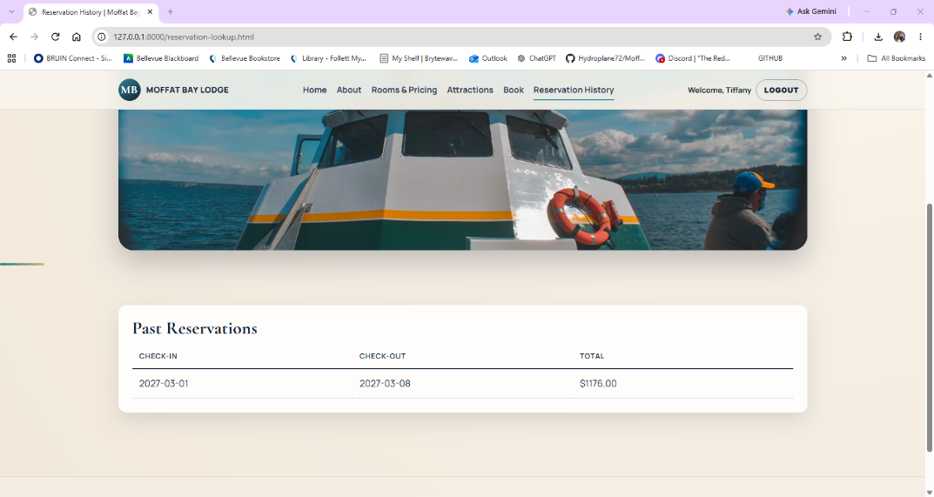
4 | Open or click Reservation History. | The Reservation History page sends a request to the API using the logged-in customer's ID. | Pass | Pass  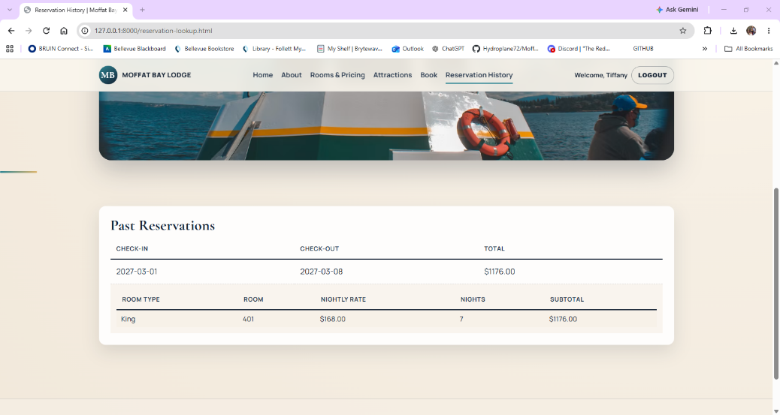
5 | Review the reservation history displayed. | The API retrieves the customer's reservations from MySQL and the correct reservation information appears on the page. | Pass | Pass  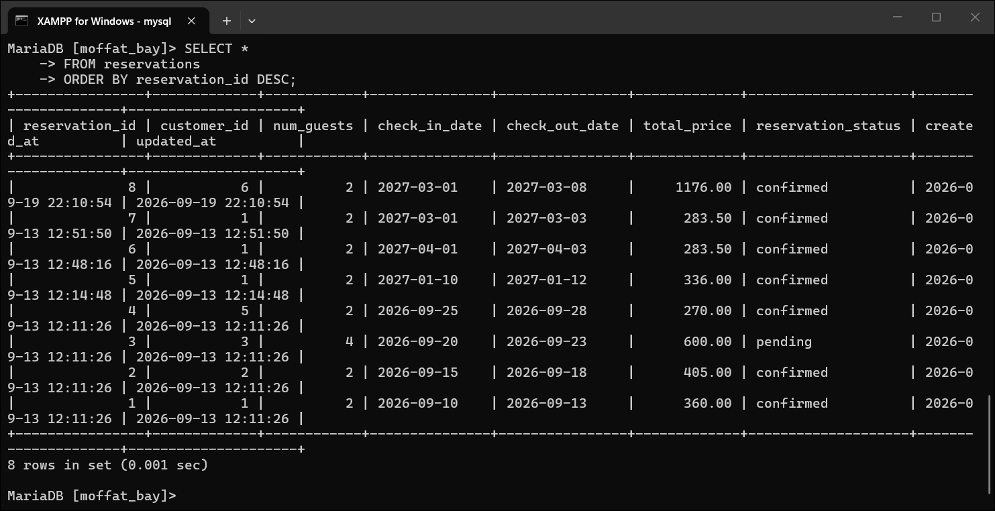
Comments | The Reservation Lookup feature worked as expected during testing. I was able to start the database and API, open the Reservation History page, log in with an account that had an existing reservation, and view the correct reservation information. The page successfully connected to the MySQL database and returned the reservation tied to the logged-in customer.

Test 2 | Verify Reservation Data Matches MySQL Data
 | Test Objective: Verify that the Reservation Lookup page correctly displays the correct user's reservation information. | Developer: Rashai Robertson  Date tested: 2026/09/18 | Peer tester: Tiffany Davidson  Date tested: 2026/09/19
Step | Action | Expected results: | Developer pass/fail | Tester pass/fail  + Screenshot
1 | Login to your account | Database accepts login and Api’s load | Pass | Pass  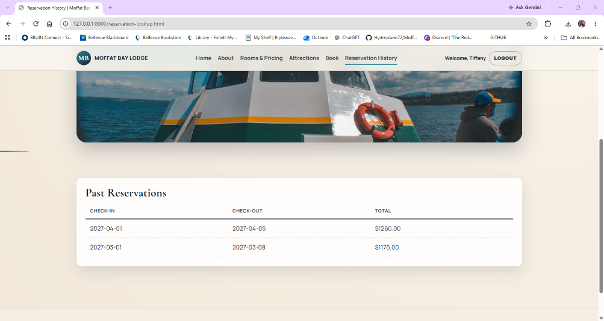
2 | Ensure that the account has history. | Account has or had a reservation. | Pass | Pass  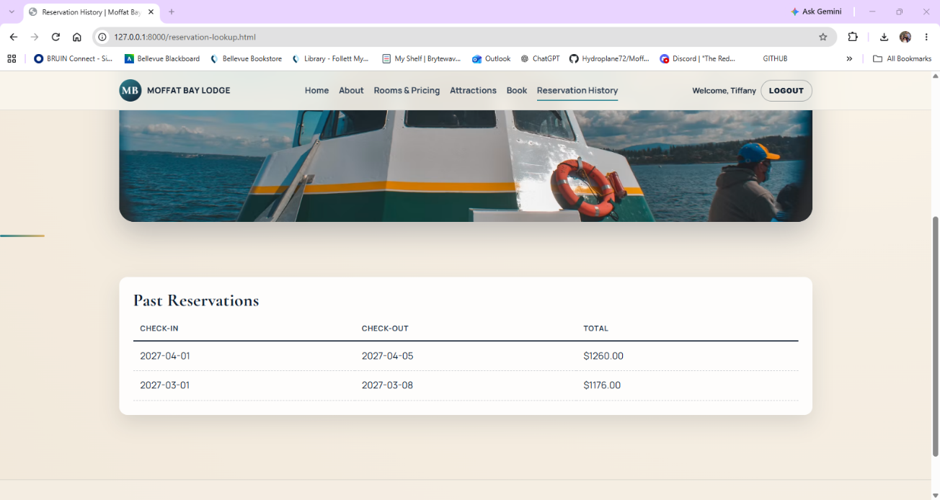
3 | Click “Reservation History” | The Reservation Lookup page loads successfully. | Pass | Pass  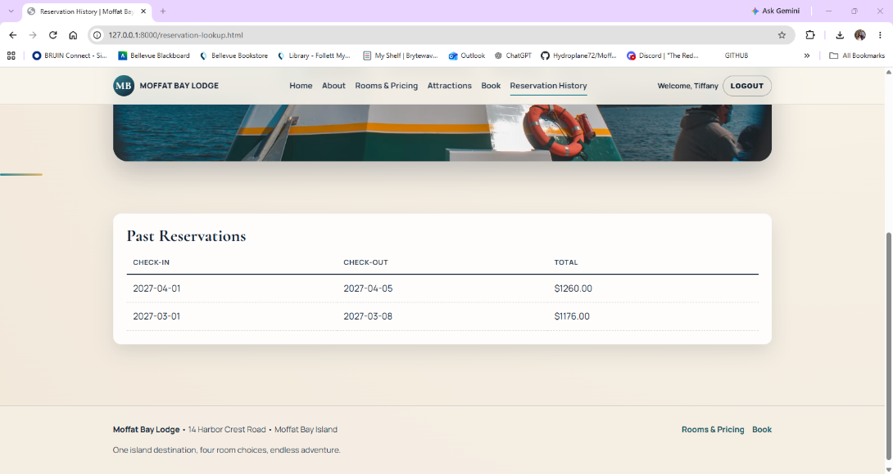
4 | Review the reservation information displayed on the page. | The information should belong to the account that is logged in | Pass | Pass  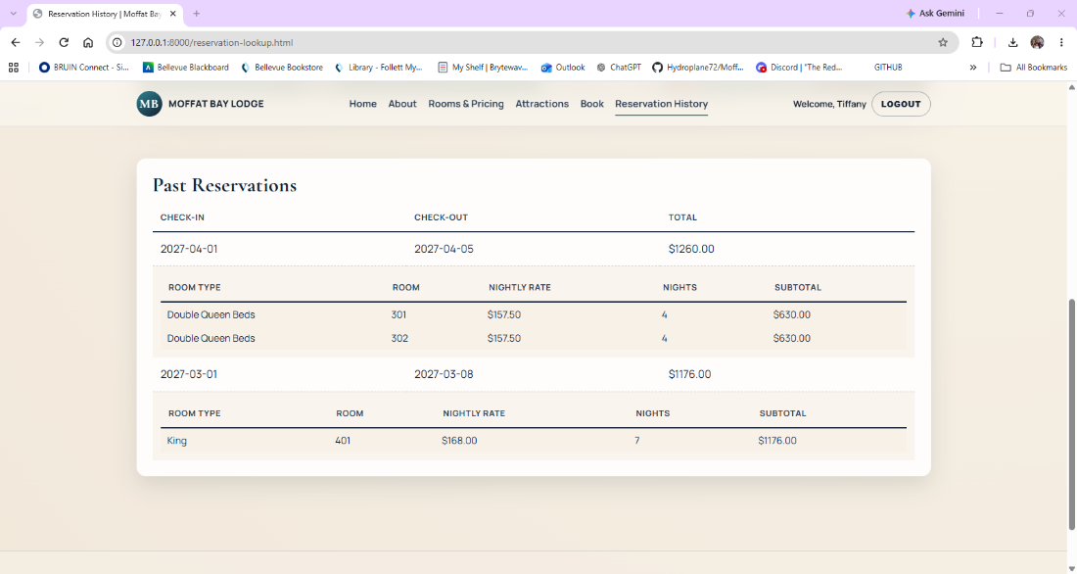
5 | Check the database in MySQL to ensure it matches | The correct information was shown on the Reservation Lookup page. | Pass | Pass  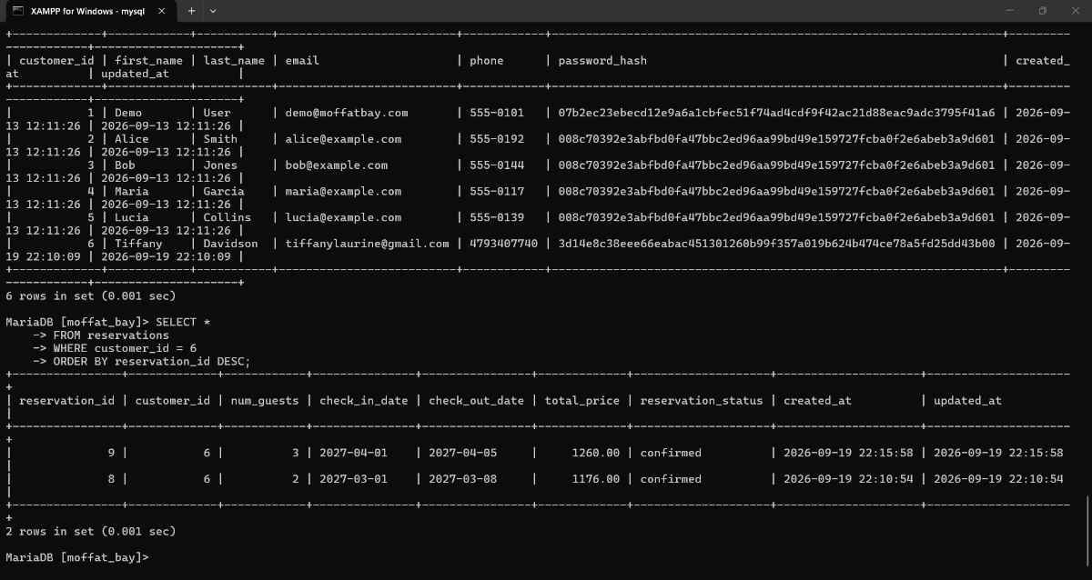
Comments | The reservation information displayed on the Reservation History page matched the data stored in MySQL for customer ID 6. I compared the reservation shown on the website with the corresponding database record and confirmed that the information belonged to the correct account. No reservation data from another customer was displayed.

Test 3 | Verify Reservation Details Expand
 | Test Objective: Verify that clicking a reservation displays the room details associated with that reservation. | Developer: Rashai Robertson  Date tested: 2026/09/18 | Peer tester: Tiffany Davidson  Date tested: 2026/09/19
Step | Action | Expected results: | Developer pass/fail | Tester pass/fail  + Screenshot
1 | Login to an account with history | Login succeeds. | Pass | Pass  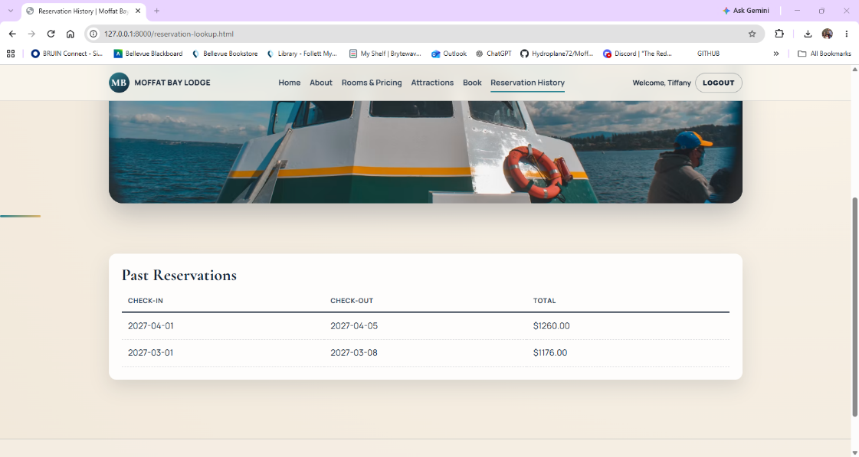
2 | Open Reservation History. | The account's reservations appear. | Pass | Pass  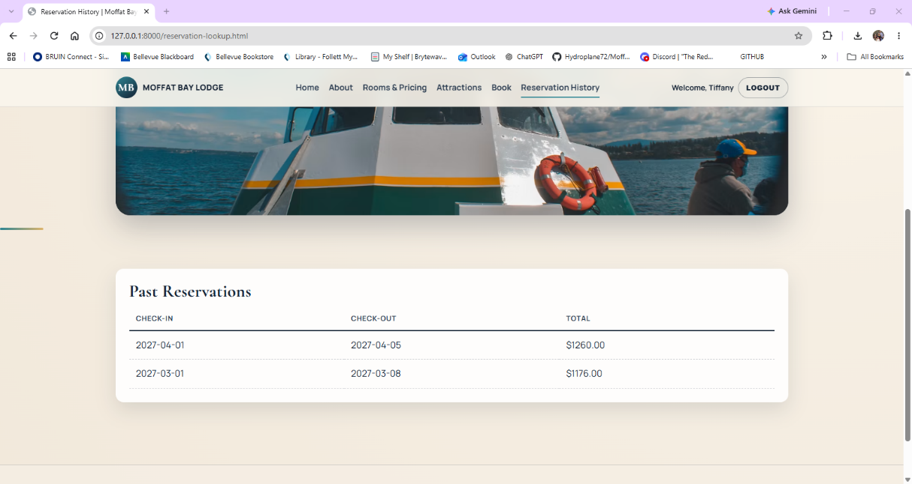
3 | Click one of the reservation rows. | The selected reservation expands. | Pass | Pass  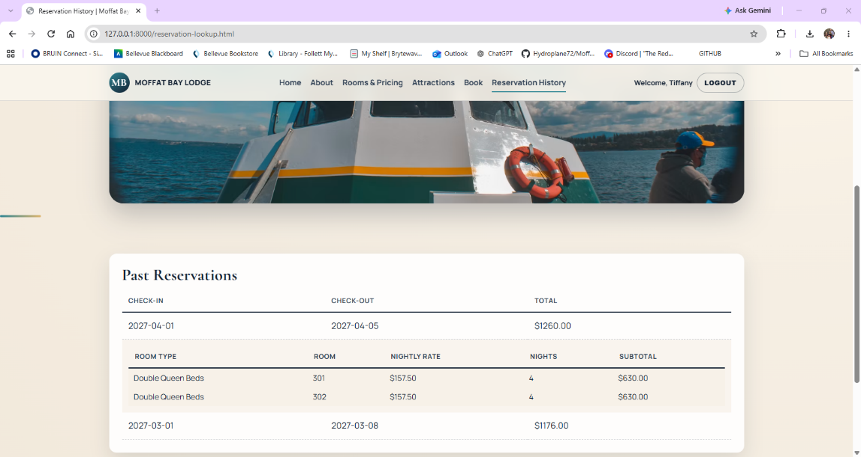
4 | Review the expanded information. | Room Type, Room Number, Nightly Rate, Nights, and Subtotal are displayed. | Pass | Pass  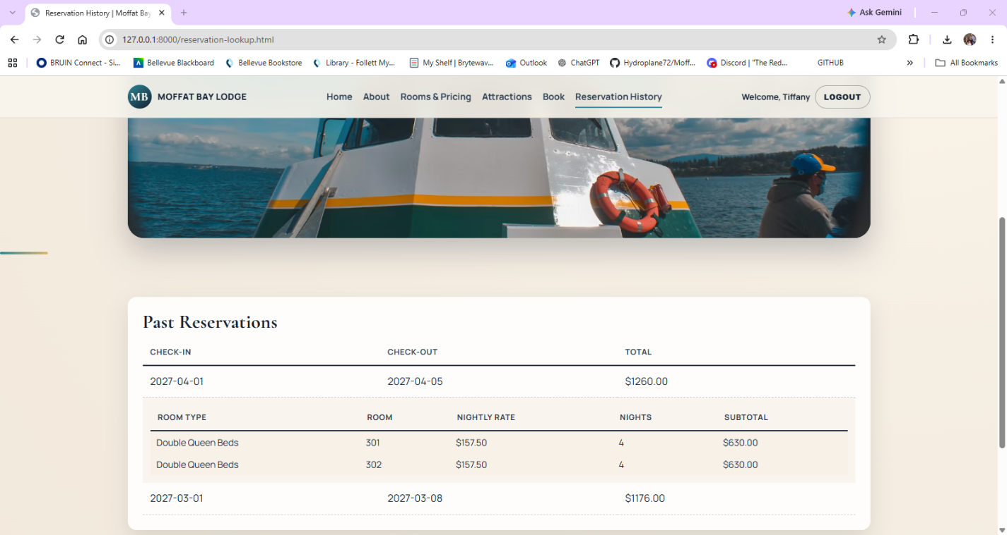
5 | Click the reservation row again. | The expanded reservation details collapse. | Pass | Pass  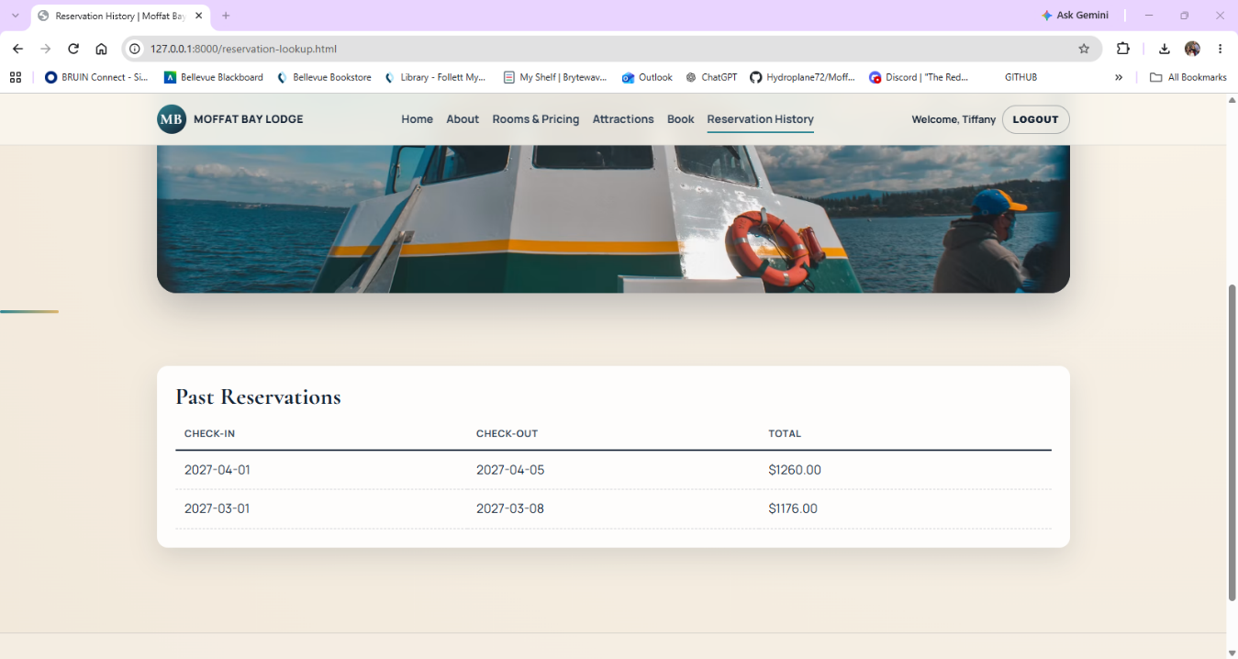
Comments | The reservation expanded and collapsed correctly during testing. When expanded, the page displayed the room type, room number, nightly rate, number of nights, and subtotal as expected. The feature worked without errors and showed the correct reservation details.

Test 4 | Verify No History Message
 | Test Objective: Verify that an account with no previous reservations receives the correct message instead of incorrect reservation information | Developer: Rashai Robertson  Date tested: 2026/09/18 | Peer tester: Tiffany Davidson  Date tested: 2026/09/19
Step | Action | Expected results: | Developer pass/fail | Tester pass/fail  + Screenshot
1 | Login to an account with no history | Login succeeds. | Pass | Pass  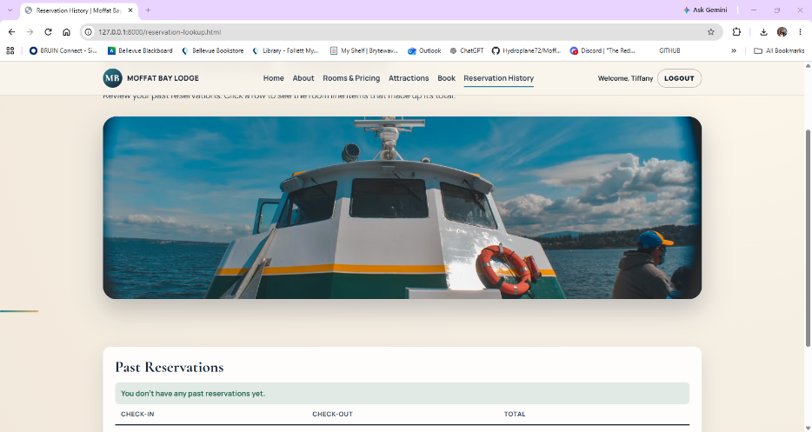
2 | Open Reservation History. | The Reservation History page loads successfully. | Pass | Pass  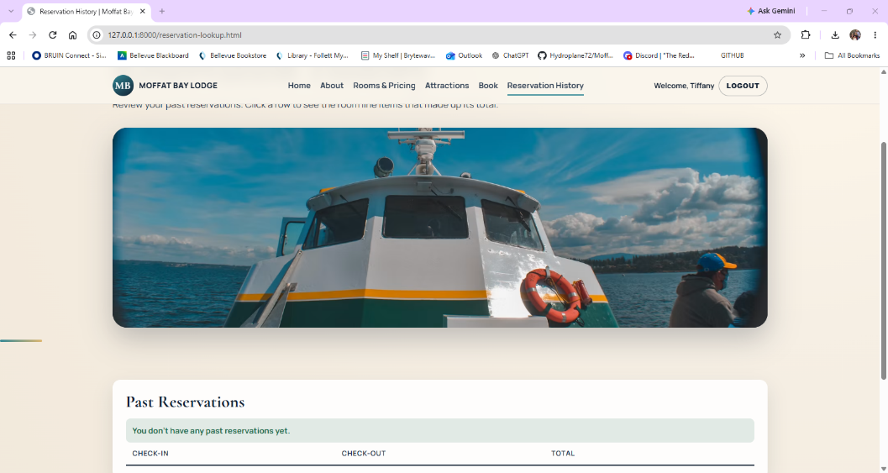
3 | Allow the page to request the customer's reservation history. | The API successfully processes the request. | Pass | Pass  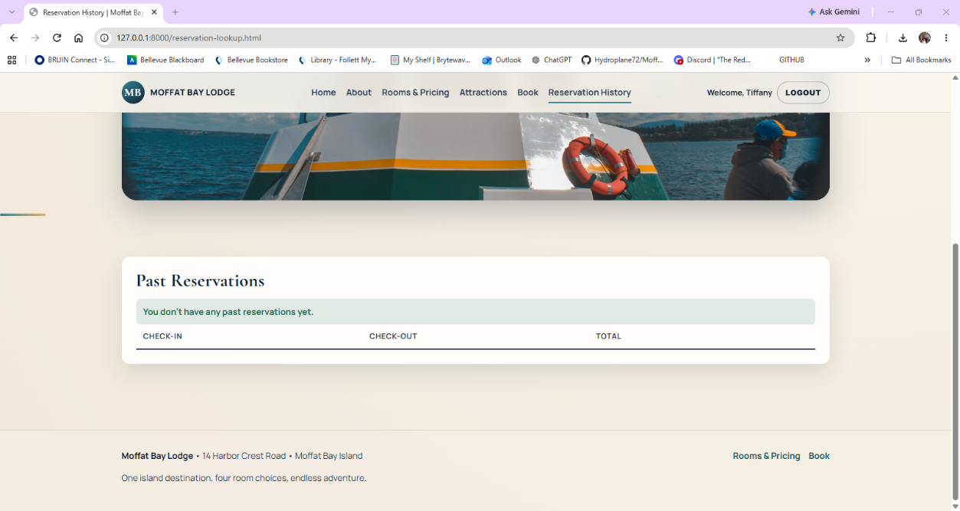
4 | Review the page. | "You don't have any past reservations yet." is displayed. | Pass | Pass  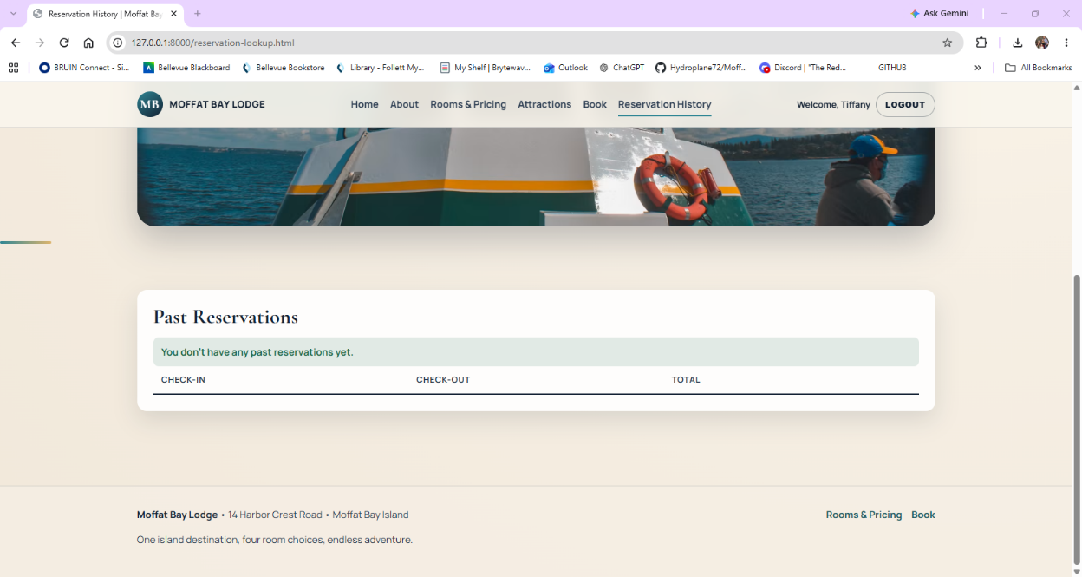
5 | Check for reservation records. | No reservation belonging to another customer is displayed. | Pass | Pass  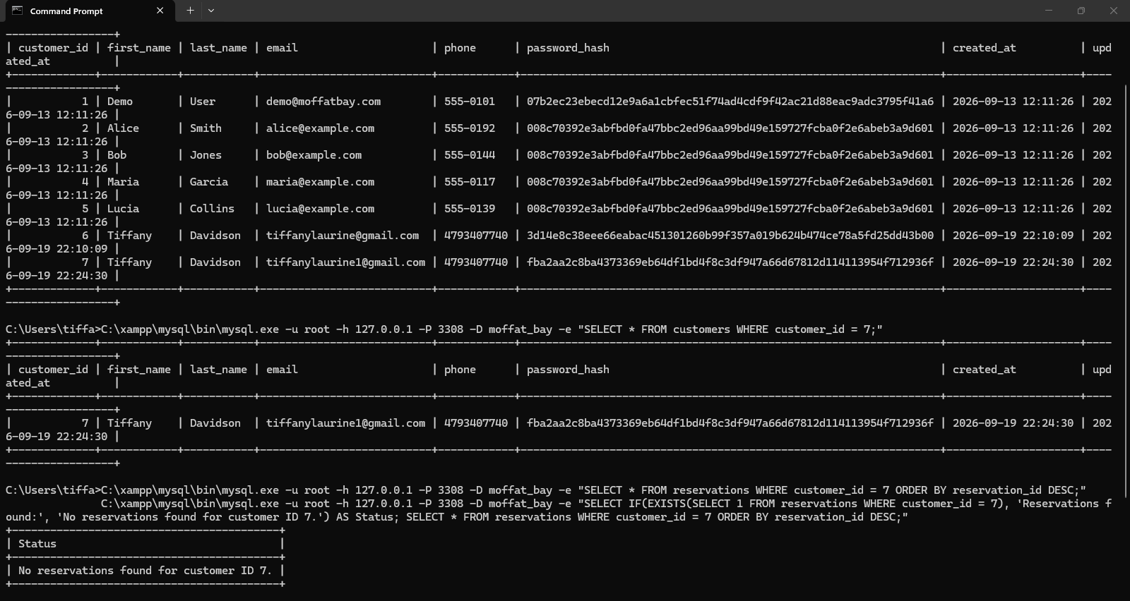
Comments | The Reservation History page handled an account with no previous reservations correctly. The page displayed the expected message stating that there were no past reservations and did not show reservation information from another customer. The API processed the request without errors and returned the correct result for the logged-in account.

Test 5 | Reservation History Requires a Customer ID
 | Test Objective:  Verify a request is rejected when the customer_id query parameter is missing so reservation history cannot be requested without identifying a customer. | Developer: Brayan Covarrubias  Date tested: 2026/09/18 | Peer tester: Tiffany Davidson  Date tested: 2026/09/19
Step | Action | Expected results: | Developer  pass/fail | Tester pass/fail  + Screenshot
1 | Run the dev server and navigate to http://127.0.0.1:8000/api/reservations/history with no customer ID query appended. | The browser displays a JSON error response. | Pass | Pass  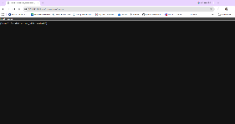
2 | Open DevTools, switch to the Network tab, and reload the page. | The response status is HTTP 400. | Pass | Pass  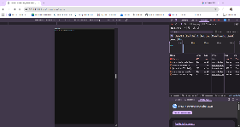
3 | Navigate to http://127.0.0.1:8000/reservation-lookup.html without logging in. | The page automatically redirects to login.html because no customer ID can be resolved. | Pass | Pass  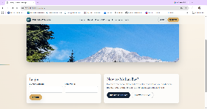
4 | Run python -m pytest src/api/tests/test_reservation_history_api.py::test_history_requires_customer_id -v | The targeted FT-RH-01 automated test finishes with PASSED. | Pass | Pass  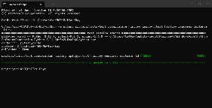
Comments | The Reservation History validation worked correctly during testing. The API rejected the request when no customer ID was provided, returned the expected 400 response, and redirected an unauthenticated user to the login page. The FT-RH-01 automated test also passed successfully, confirming the validation is working as expected.

Test 6 | Reservation History Returns the Seeded Reservation with Line Items
 | Test Objective:  Verify the customer's past reservation and its room line items are returned so a returning guest can review booking details. | Developer: Brayan Covarrubias  Date tested: 2026/09/18 | Peer tester: Tiffany Davidson  Date tested: 2026/09/19
Step | Action | Expected results: | Developer  pass/fail | Tester pass/fail  + Screenshot
1 | Run the dev server and navigate to http://127.0.0.1:8000/login.html. | The page loads successfully with no broken UI elements. | Pass | Pass  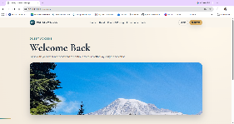
2 | Log in with the demo account (demo@moffatbay.com / DemoPass1). | Login succeeds and the user is redirected to reservation.html. | Pass | Pass  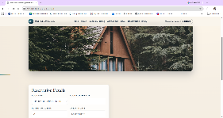
3 | Navigate to http://127.0.0.1:8000/reservation-lookup.html or use the Reservation History tab. | At least one past reservation displays for the demo account with the correct dates and pricing. | Pass | Pass  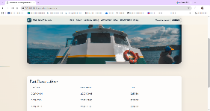
4 | Click a reservation to expand its details. | Room number, nightly rate, total nights, and line-item price are displayed. | Pass | Pass  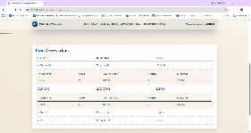
5 | Run python -m pytest src/api/tests/test_reservation_history_api.py::test_history_returns_seeded_reservation_with_line_items -v | The targeted FT-RH-02 automated test finishes with PASSED. | Pass | Pass  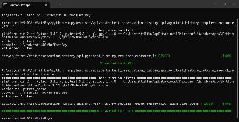
Comments | The seeded demo reservation displayed correctly in Reservation History with the expected dates and pricing. Expanding the reservation showed the room number, nightly rate, number of nights, and line-item pricing correctly. The FT-RH-02 automated test also passed successfully, confirming the reservation history data is being returned as expected.

Test 7 | About Page Loads with the Contact Us Section
 | Test Objective:  Verify the Contact Us section is integrated into the About page, displays the complete inquiry form, uses the production about.js script, and no separate Contact page link remains. | Developer: Brayan Covarrubias  Date tested: 2026/09/18 | Peer tester: Tiffany Davidson  Date tested: 2026/09/20
Step | Action | Expected results: | Developer  pass/fail | Tester pass/fail  + Screenshot
1 | Start MySQL and run python src/api/startup_api.py, then open http://127.0.0.1:8000/about.html. | The About page loads successfully with no broken page elements. | Pass | Pass  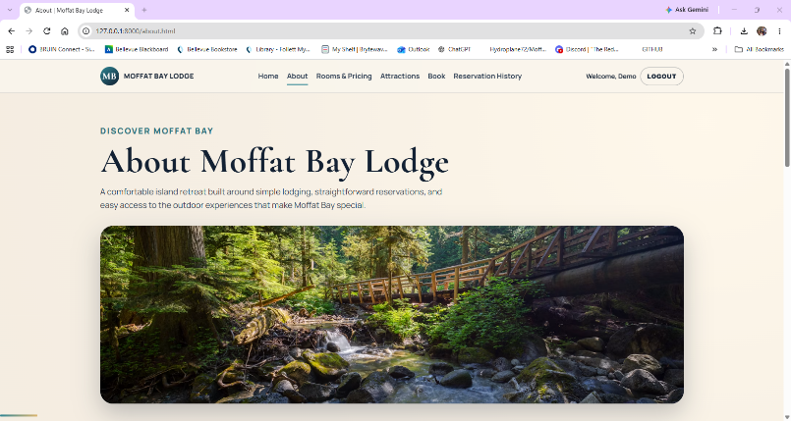
2 | Scroll to the Contact Moffat Bay Lodge section. | The section displays Full Name, Email, Subject, Message, and Send Message controls. | Pass | Pass  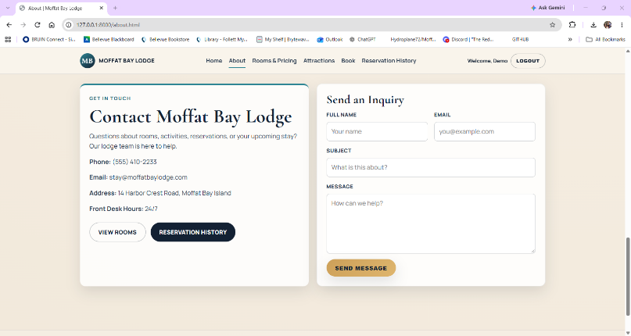
3 | Check the main navigation and footer links. | There is no separate contact.html link or dead Contact-page navigation. | Pass | Pass
4 | Open DevTools Elements or View Page Source and locate the Contact section. | The page contains id="contact", id="contact-form", and assets/js/about.js. | Pass | Pass  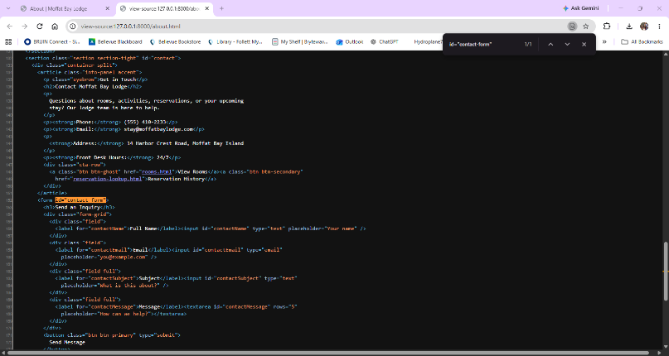
5 | Run python -m pytest src/api/tests/test_about_api.py::test_about_page_loads_with_contact_section_and_script -v | The targeted FT-AB-01 automated test finishes with PASSED. | Pass | Pass  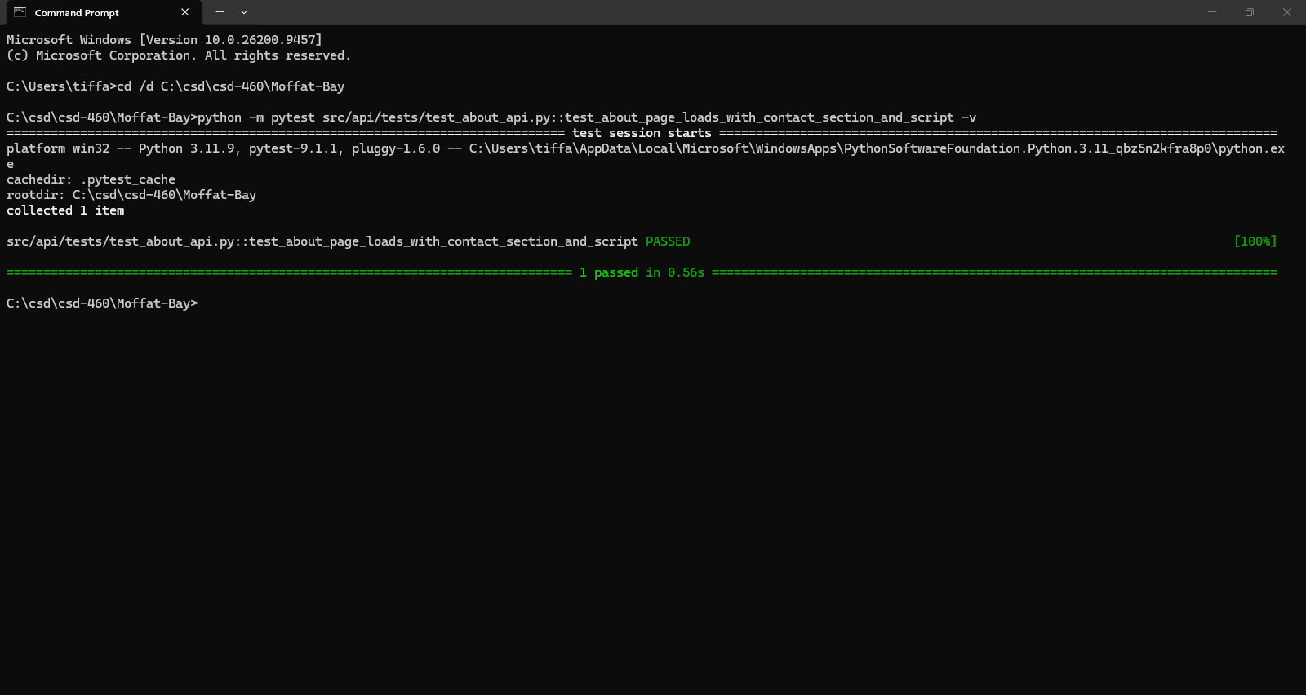
Comments | The About page loaded correctly and displayed the Contact Us section with all required fields. I confirmed that the contact section is part of the About page, the correct section IDs and about.js file are present, and the automated FT-AB-01 test passed successfully.

Test 8 | Contact Us Form Inserts a New Message into the Database
 | Test Objective:  Verify the Contact Us form on the About page submits through the backend and stores a new inquiry in the ContactMessages table. | Developer: Brayan Covarrubias  Date tested: 2026/09/18 | Peer tester: Tiffany Davidson  Date tested: 2026/09/20
Step | Action | Expected results: | Developer  pass/fail | Tester pass/fail  + Screenshot
1 | Open the About page Contact Us section and enter unique QA values in Full Name, Email, Subject, and Message. | All required contact fields accept the QA values. | Pass | Pass  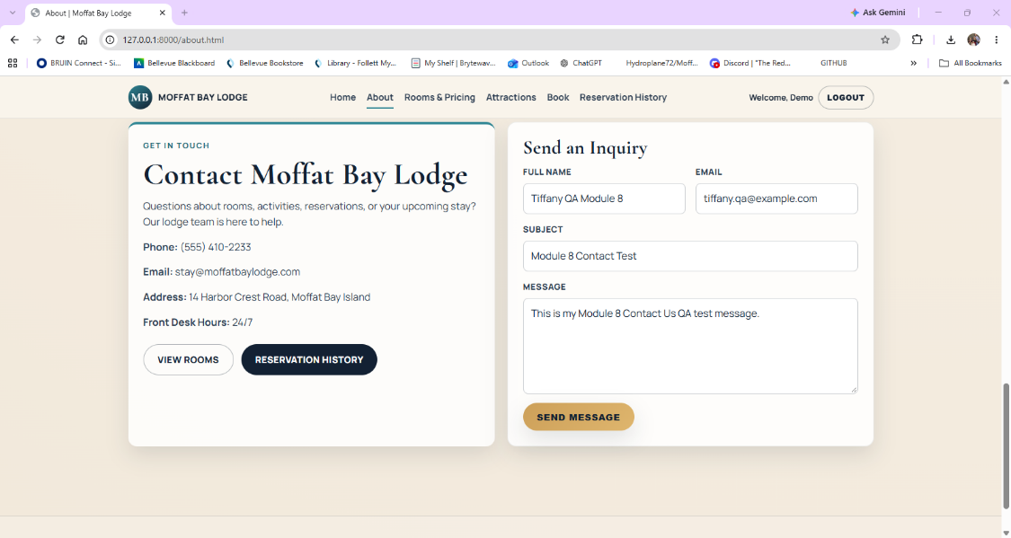
2 | Click Send Message. | The page displays "Thanks! Your message has been sent." in the success message area. | Pass | Pass  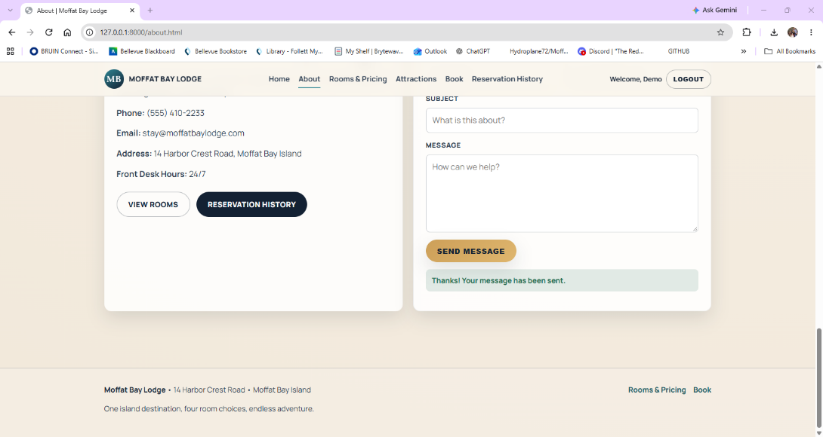
3 | Run SELECT * FROM ContactMessages ORDER BY message_id DESC LIMIT 1; in MySQL. | The newest row contains the QA name, email, subject, and message that were submitted. | Pass | Pass  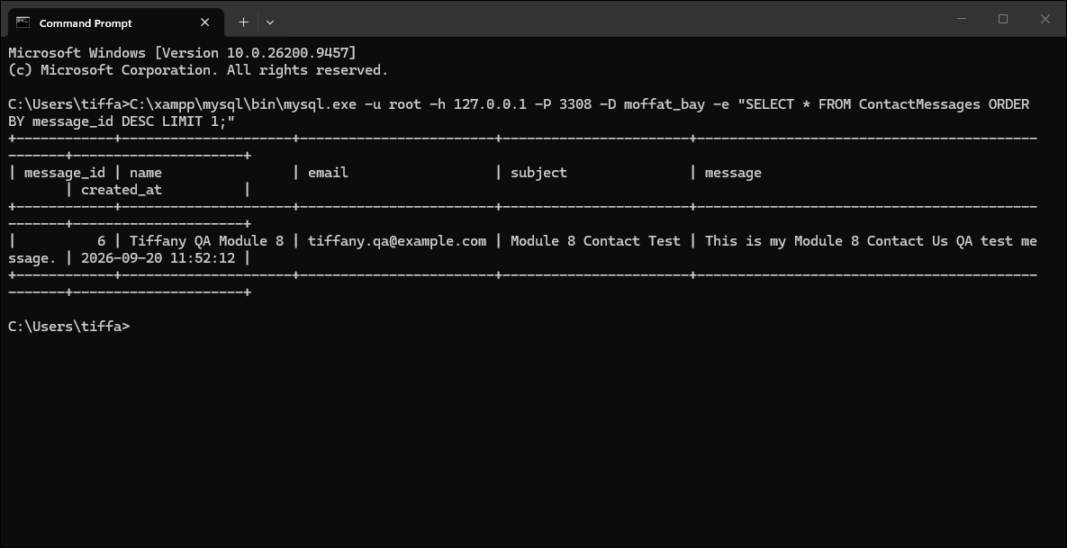
4 | Run python -m pytest src/api/tests/test_about_api.py::test_contact_api_inserts_new_message_into_database -v | The targeted FT-AB-02 automated test finishes with PASSED. | Pass | Pass  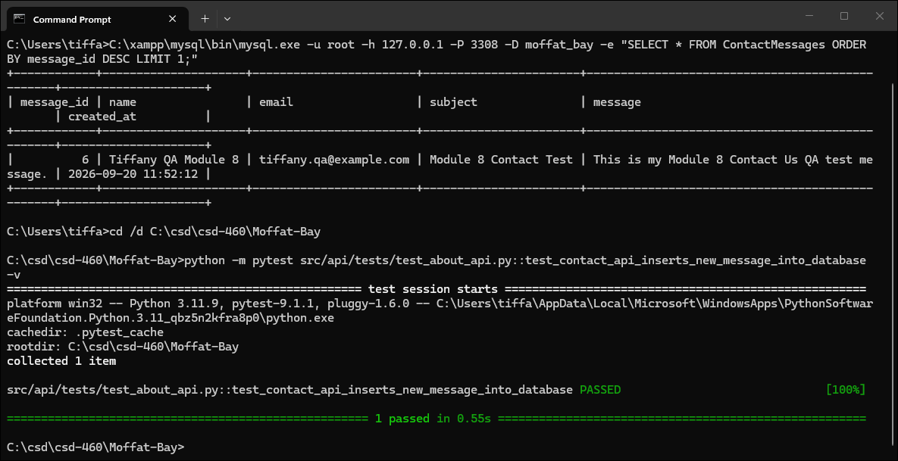
Comments | The Contact Us form accepted all required information and submitted the message successfully. I verified that the submitted information was saved correctly in the ContactMessages table, and the automated FT-AB-02 test passed successfully. No correction was needed for this test.

